# Setup Challenge 3: The Black Box

1. Create the application java swing GUI with JPasswordField and Button beneath it:

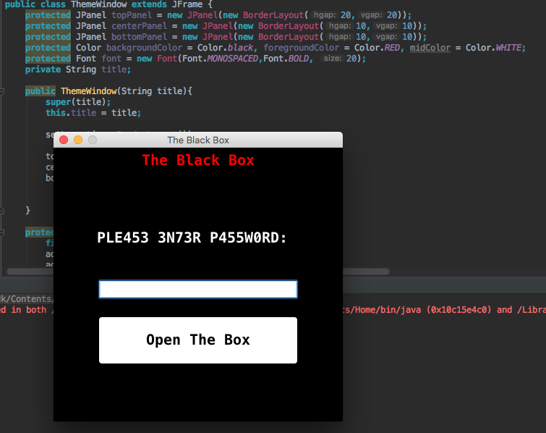

1. Add an Action Listener to the button so every time the user enters a wrong password a JFrame with a random gif image that tells him his wrong will pop up, took the gifs from google images writing “Wrong”.

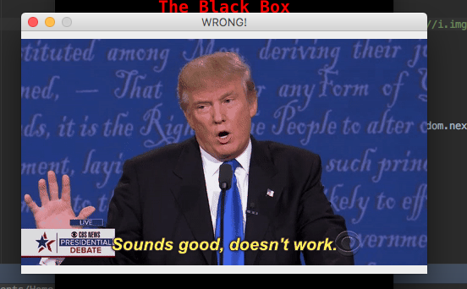

1. 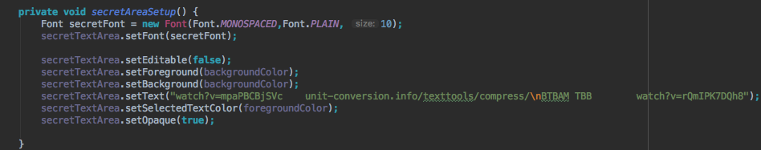Add a Text Area beneath the button, color his background and foreground black so it will be impossible to see the text in it without selecting it

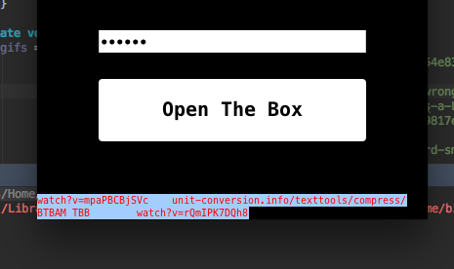

1. In this area text put:
2. An online text compression tool
3. 2 suffixes of YouTube videos which looks kind of “hashed” just to mess with their heads ;)
4. 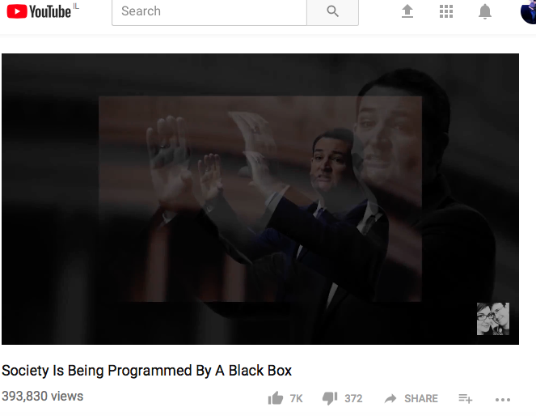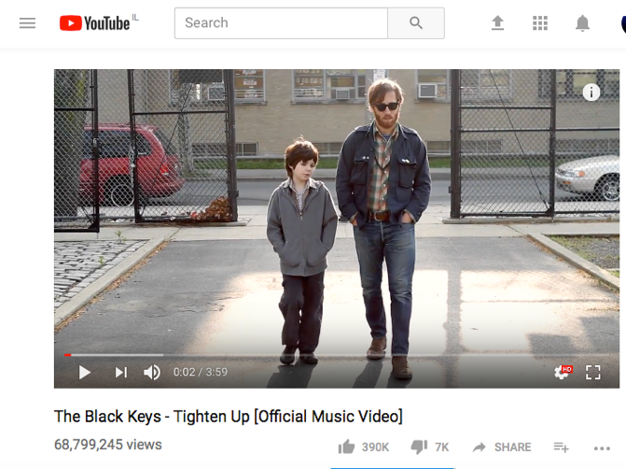BTBAM TBB which are acronyms for *Between the Buried and Me The Black Box* which will be the flag eventually, but they don’t know that yet, so why not?
5. Hide a string named *PASSWORD* so the user will know he’s in the right place to look for answer (the password itself has nothing to do with answer)



1. 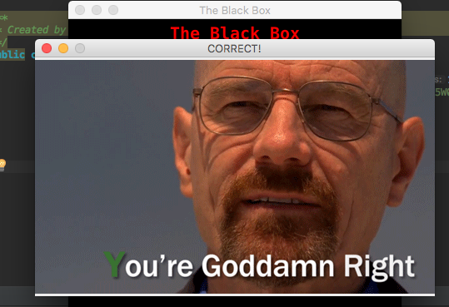Just for fun, if the user enters the right answer he gets a “Correct” gif

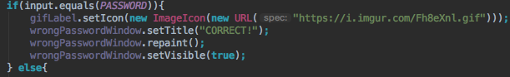

1. Using the compression tool we gave him in the invisible text area, compress the flag and some text after it to make it longer.

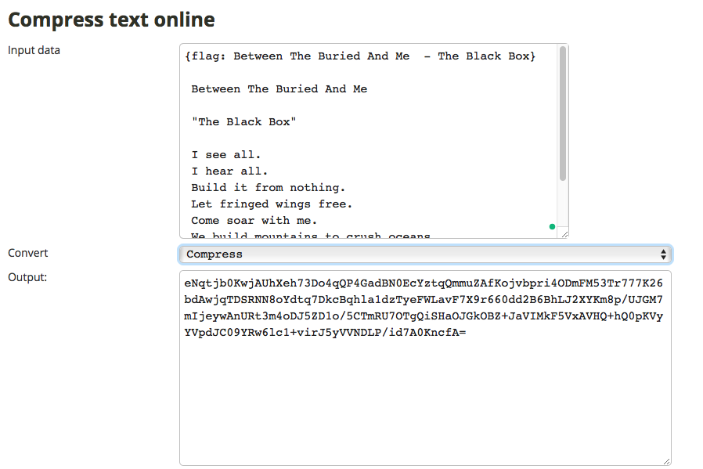

1. Hide this inside a String in one of the code files

